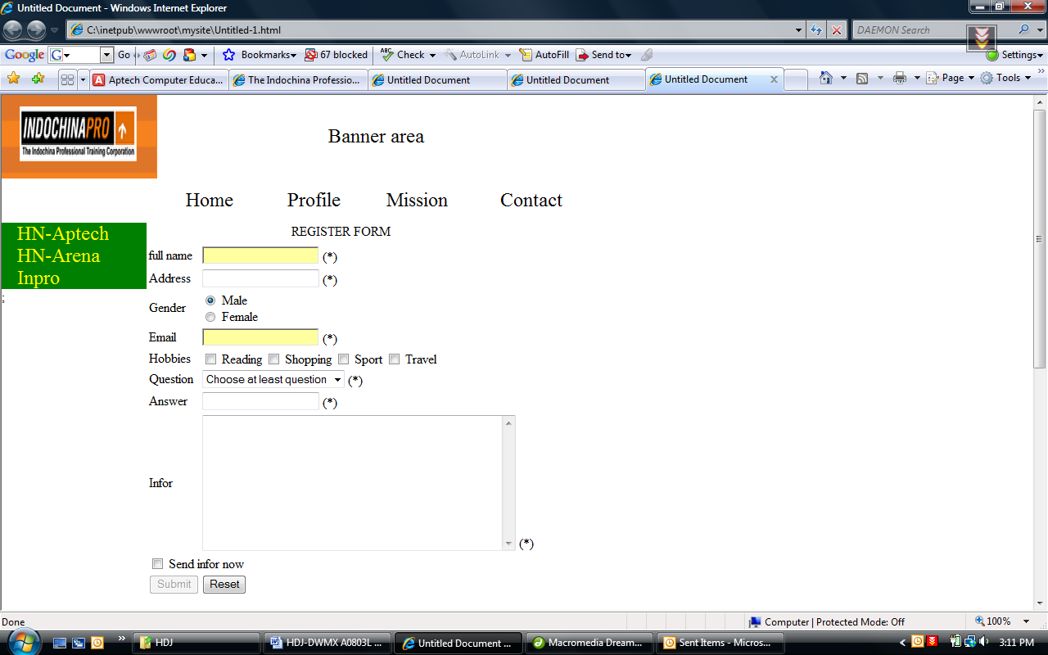
Content:
- Question:
+ Choose at least question
+ Your Family name
+ Your first teacher name
Require
- When user Click on Reset Button, all field must be cleared. [0.5]
- When user Click on Submit Button, following validations will be performed: [9]
When a textbox become current element, its background change to yellow color, when it lost focus the background color return to white color
All fields that have “*” in the label must be inputted (not empty). If one of them is empty, Message Box will display “your …. must be inputted” (… is field’s name)
Full name: accept only characters from a to z (OR from A to Z ) and space.
Email must in correct format: userName@domainName (Example : aptech@sun.com.uk)
Question must choose at least one
When user click “send infor now” the Submit button is enable, otherwise the submit button is disabled

- If no error, show message “You have registered success”

